Rashmee Prakash

**Flowchart**

Legends:

First Level: Homepage

Second level:

Third level:

Home

EVENTS

SITE MAP

REPORT ABUSE

GET UPDATES

CONTACT US

DONATE

GET INVOLVED

GET HELP

OUR WORK

THE ISSUE

ABOUT US

References

CALENDAR

WALLPAPERS

|  |  |  |
| --- | --- | --- |
| **Storyboard Template for Multimedia Product Development** | | |
| Client Name: Stop Domestic Violence | | |
| Project Title: Non-Profit Organization Website | | |
| Last Update: April 29, 2013 | | Name of Designer: Rashmee Prakash |
| Panel/Page ID: index.html | | Panel/Page/Frame No: Home |
| Description of Copy text: | Home Text: No text | |
| User Interactions: | Navigation buttons, on the left side of each page. Ribbons at top and bottom to take you to flash animation and next page. Clicking on the logo takes you back to the Homepage.  Flash animation, with user-controlled button. Press button to continue playing the animation to the end. | |
| Hyper Links: | * index.html(clicking the logo will also take you to the homepage) * about_us.html * issue.html * Our_work.html * Get_Help.html * Get_Involved.html * Events.html * Donate.html * Contact_Us.html * Report_Abuse.html * Site_Map.html | |
| Audio inclusion and controls: | None | |
| Video inclusion and controls: | None | |
| Color specifications: | Page Background: Blue Grey (#B81324)  Navigation: White (#FFF);  Skip Navigation Link, Time and Date: #FF9  Body: Heading: Black, other content : dark purple (#306)  Hyperlink/Hover Link: White(#FFF)/Pink(#639)  Header: Border: 6px double #B81324, Background image: Stripes.png  Sidebar: background-color: #8B4789  Footer: background-color: #FFF, border:6px groove #B81324; Disclaimer: Black(#000), Email id: Deep red(#900) | |
| Panel Layout | | |

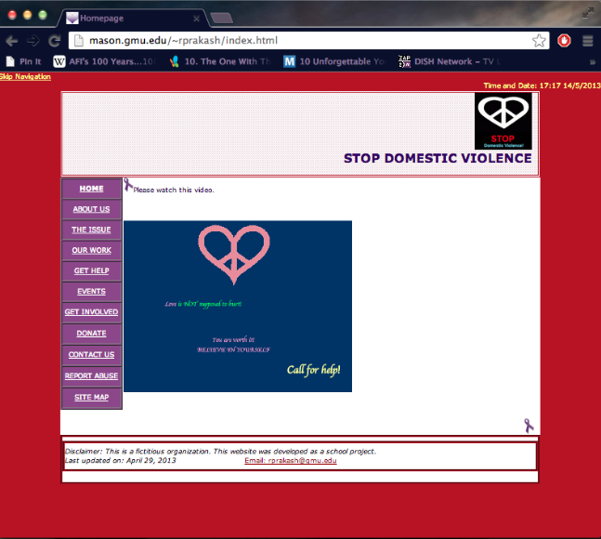

|  |  |  |
| --- | --- | --- |
| **Storyboard Template for Multimedia Product Development** | | |
| Client Name: Stop Domestic Violence | | |
| Project Title: Non-Profit Organization Website | | |
| Last Update: April 29, 2013 | | Name of Designer: Rashmee Prakash |
| Panel/Page ID: about_us.html | | Panel/Page/Frame No: About Us |
| Description of Copy text: | Home Text: About the organization  Font: Verdana, Arial, Helvetica, sans-serif  Font Size: 12 | |
| User Interactions: | Navigation buttons, on the left side of each page. An image link to another page(Wallpapers.html). Ribbons at top and bottom to take you to previous and next page. Clicking on the logo takes you back to the Homepage. | |
| Hyper Links: | * index.html(clicking the logo will also take you to the homepage) * about_us.html * image link to wallpaper.html * issue.html * our_work.html * get_help.html * get_involved.html * events.html * donate.html * contact_us.html * report_abuse.html * site_map.html | |
| Audio inclusion and controls: | None | |
| Video inclusion and controls: | None | |
| Color specifications: | Page Background: Blue Grey (#B81324)  Navigation: White (#FFF);  Skip Navigation Link, Time and Date: #FF9  Body: Heading: Black, other content : dark purple (#306)  Hyperlink/Hover Link: White(#FFF)/Pink(#639)  Header: Border: 6px double #B81324, Background image: Stripes.png  Sidebar: background-color: #8B4789  Footer: background-color: #FFF, border:6px groove #B81324; Disclaimer: Black(#000), Email id: Deep red(#900) | |
| Panel Layout | | |

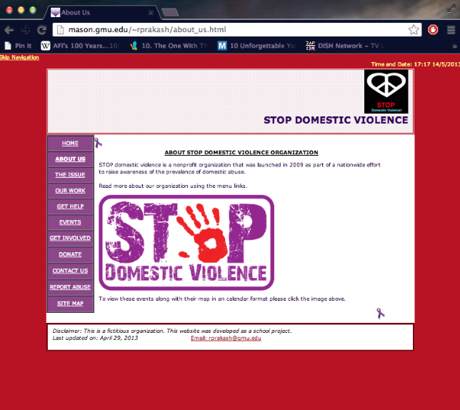

|  |  |  |
| --- | --- | --- |
| **Storyboard Template for Multimedia Product Development** | | |
| Client Name: Stop Domestic Violence | | |
| Project Title: Non-Profit Organization Website | | |
| Last Update: April 29, 2013 | | Name of Designer: Rashmee Prakash |
| Panel/Page ID: Wallpapers.html | | Panel/Page/Frame No: Wallpapers |
| Description of Copy text: | Home Text: Thumbnail Pictures for wallpapers which when clicked(image links) will open in up in their original size pop up windows.  Font: Verdana, Arial, Helvetica, sans-serif  Font Size: 12 | |
| User Interactions: | An image link to another page (Wallpapers.html). Clicking on the logo takes you back to the Homepage. | |
| Hyper Links: | * index.html (clicking the logo will take you to the homepage) * Clicking “here” on the page will take you back to about_us.html * img1.html(image link leads here) * img3.html(image link leads here) * img5.html(image link leads here) * img6.html(image link leads here) * img7.html(image link leads here) * img8.html(image link leads here) * img9.html(image link leads here) | |
| Audio inclusion and controls: | None | |
| Video inclusion and controls: | None | |
| Color specifications: | Page Background: Blue Grey (#B81324)  Navigation: White (#FFF);  Skip Navigation Link, Time and Date: #FF9  Body: Heading: Black, other content : dark purple (#306)  Hyperlink/Hover Link: White(#FFF)/Pink(#639)  Header: Border: 6px double #B81324, Background image: Stripes.png  Footer: background-color: #FFF, border:6px groove #B81324; Disclaimer: Black(#000), Email id: Deep red(#900) | |
| Panel Layout | | |

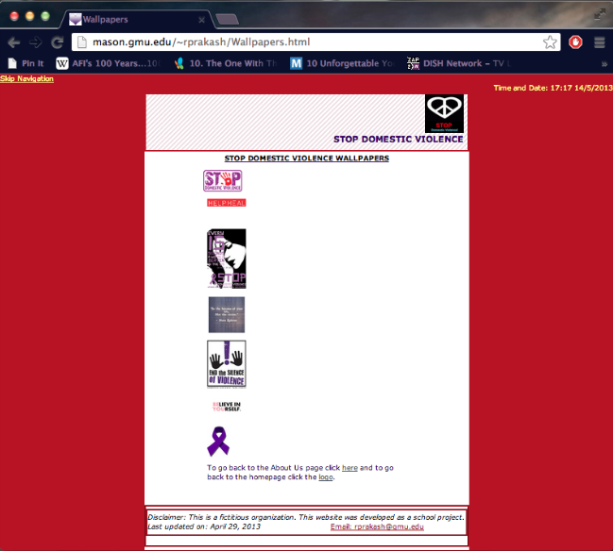

|  |  |  |
| --- | --- | --- |
| **Storyboard Template for Multimedia Product Development** | | |
| Client Name: Stop Domestic Violence | | |
| Project Title: Non-Profit Organization Website | | |
| Last Update: April 29, 2013 | | Name of Designer: Rashmee Prakash |
| Panel/Page ID: issue.html | | Panel/Page/Frame No: The Issue |
| Description of Copy text: | Home Text: Talks about domestic violence and its after effects. External links to webpages.  Font: Verdana, Arial, Helvetica, sans-serif  Font Size: 12 | |
| User Interactions: | Navigation buttons, on the left side of each page. Ribbons at top and bottom to take you to previous and next page. Clicking on the logo takes you back to the Homepage.  Flash animation, with user-controlled button. Press button to continue playing the animation to the end. | |
| Hyper Links: | * index.html(clicking the logo will also take you to the homepage) * about_us.html * issue.html * our_work.html * get_help.html * get_involved.html * events.html * donate.html * contact_us.html * report_abuse.html * site_map.html | |
| Audio inclusion and controls: | None | |
| Video inclusion and controls: | None | |
| Color specifications: | Page Background: Blue Grey (#B81324)  Navigation: White (#FFF);  Skip Navigation Link, Time and Date: #FF9  Body: Heading: Black, other content : dark purple (#306)  Hyperlink/Hover Link: White(#FFF)/Pink(#639)  Header: Border: 6px double #B81324, Background image: Stripes.png  Sidebar: background-color: #8B4789  Footer: background-color: #FFF, border:6px groove #B81324; Disclaimer: Black(#000), Email id: Deep red(#900) | |
| Panel Layout | | |

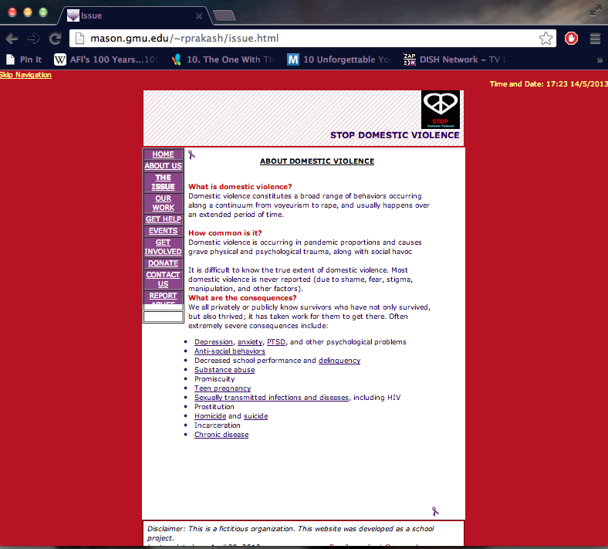

|  |  |  |
| --- | --- | --- |
| **Storyboard Template for Multimedia Product Development** | | |
| Client Name: Stop Domestic Violence | | |
| Project Title: Non-Profit Organization Website | | |
| Last Update: April 29, 2013 | | Name of Designer: Rashmee Prakash |
| Panel/Page ID: our_work.html | | Panel/Page/Frame No: Our Work |
| Description of Copy text: | Home Text: The way we reach out to people.  Font: Verdana, Arial, Helvetica, sans-serif  Font Size: 12 | |
| User Interactions: | Navigation buttons, on the left side of each page.  Ribbons at top and bottom to take you to previous and next page. Clicking on the logo takes you back to the Homepage.  Flash animation, with user-controlled button. Press button to continue playing the animation to the end. | |
| Hyper Links: | * index.html(clicking the logo will also take you to the homepage) * about_us.html * issue.html * our_work.html * get_help.html * get_involved.html * events.html * donate.html * contact_us.html * report_abuse.html * site_map.html | |
| Audio inclusion and controls: | None | |
| Video inclusion and controls: | None | |
| Color specifications: | Page Background: Blue Grey (#B81324)  Navigation: White (#FFF);  Skip Navigation Link, Time and Date: #FF9  Body: Heading: Black, other content : dark purple (#306)  Hyperlink/Hover Link: White(#FFF)/Pink(#639)  Header: Border: 6px double #B81324, Background image: Stripes.png  Sidebar: background-color: #8B4789  Footer: background-color: #FFF, border:6px groove #B81324; Disclaimer: Black(#000), Email id: Deep red(#900) | |
| Panel Layout | | |

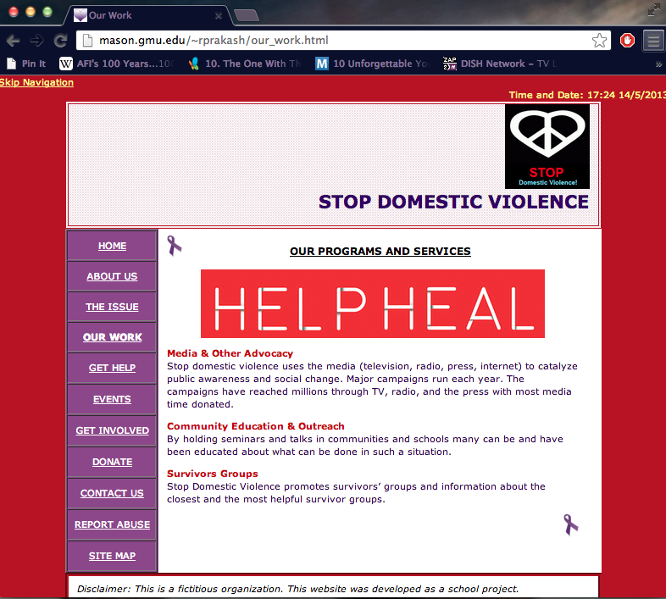

|  |  |  |
| --- | --- | --- |
| **Storyboard Template for Multimedia Product Development** | | |
| Client Name: Stop Domestic Violence | | |
| Project Title: Non-Profit Organization Website | | |
| Last Update: April 29, 2013 | | Name of Designer: Rashmee Prakash |
| Panel/Page ID: get_help.html | | Panel/Page/Frame No: Get Help |
| Description of Copy text: | Home Text: How to get help.  Font: Verdana, Arial, Helvetica, sans-serif  Font Size: 12 | |
| User Interactions: | Navigation buttons, on the left side of each page. Ribbons at top and bottom to take you to previous and next page. Clicking on the logo takes you back to the Homepage.  Flash animation, with user-controlled button. Press button to continue playing the animation to the end. | |
| Hyper Links: | * index.html(clicking the logo will also take you to the homepage) * about_us.html * issue.html * our_work.html * get_help.html * get_involved.html * events.html * donate.html * contact_us.html * report_abuse.html * site_map.html | |
| Audio inclusion and controls: | None | |
| Video inclusion and controls: | None | |
| Color specifications: | Page Background: Blue Grey (#B81324)  Navigation: White (#FFF);  Skip Navigation Link, Time and Date: #FF9  Body: Heading: Black, other content : dark purple (#306)  Hyperlink/Hover Link: White(#FFF)/Pink(#639)  Header: Border: 6px double #B81324, Background image: Stripes.png  Sidebar: background-color: #8B4789  Footer: background-color: #FFF, border:6px groove #B81324; Disclaimer: Black(#000), Email id: Deep red(#900) | |
| Panel Layout | | |

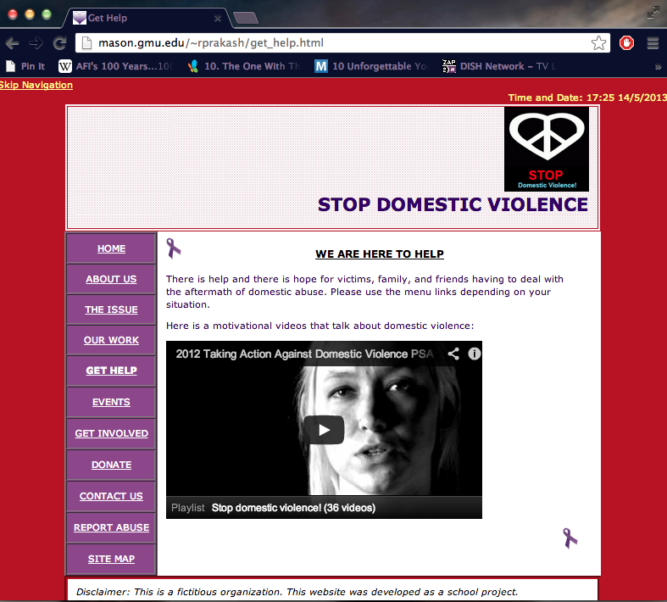

|  |  |  |
| --- | --- | --- |
| **Storyboard Template for Multimedia Product Development** | | |
| Client Name: Stop Domestic Violence | | |
| Project Title: Non-Profit Organization Website | | |
| Last Update: April 29, 2013 | | Name of Designer: Rashmee Prakash |
| Panel/Page ID: get_involved.html | | Panel/Page/Frame No: Get Involved |
| Description of Copy text: | Home Text: How to get involved with the organization.  Font: Verdana, Arial, Helvetica, sans-serif  Font Size: 12 | |
| User Interactions: | Navigation buttons, on the left side of each page. Ribbons at top and bottom to take you to previous and next page. Clicking on the logo takes you back to the Homepage.  Flash animation, with user-controlled button. Press button to continue playing the animation to the end. | |
| Hyper Links: | * index.html(clicking the logo will also take you to the homepage) * about_us.html * issue.html * our_work.html * get_help.html * get_involved.html * events.html * donate.html * contact_us.html * report_abuse.html * site_map.html | |
| Audio inclusion and controls: | None | |
| Video inclusion and controls: | None | |
| Color specifications: | Page Background: Blue Grey (#B81324)  Navigation: White (#FFF);  Skip Navigation Link, Time and Date: #FF9  Body: Heading: Black, other content : dark purple (#306)  Hyperlink/Hover Link: White(#FFF)/Pink(#639)  Header: Border: 6px double #B81324, Background image: Stripes.png  Sidebar: background-color: #8B4789  Footer: background-color: #FFF, border:6px groove #B81324; Disclaimer: Black(#000), Email id: Deep red(#900) | |
| Panel Layout | | |

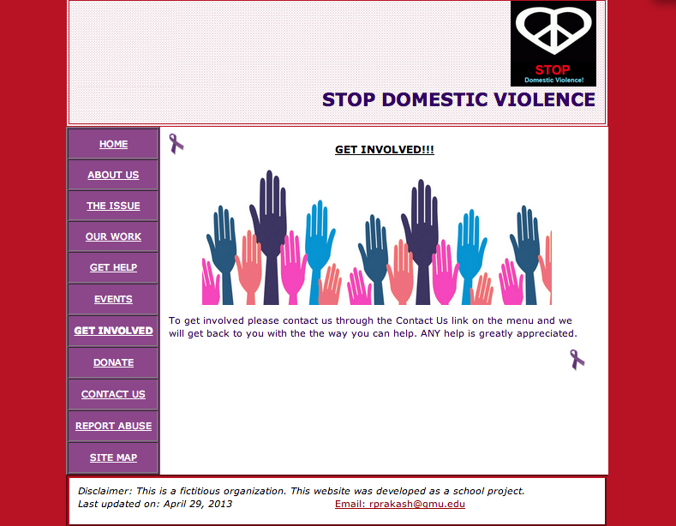

|  |  |  |
| --- | --- | --- |
| **Storyboard Template for Multimedia Product Development** | | |
| Client Name: Stop Domestic Violence | | |
| Project Title: Non-Profit Organization Website | | |
| Last Update: April 29, 2013 | | Name of Designer: Rashmee Prakash |
| Panel/Page ID: events.html | | Panel/Page/Frame No: Events |
| Description of Copy text: | Home Text: Information about upcoming events.  Font: Verdana, Arial, Helvetica, sans-serif  Font Size: 12 | |
| User Interactions: | Navigation buttons, on the left side of each page. A link(“here”) to another page(Calendar.html). Ribbons at top and bottom to take you to previous and next page. Clicking on the logo takes you back to the Homepage.  Flash animation, with user-controlled button. Press button to continue playing the animation to the end. | |
| Hyper Links: | * index.html(clicking the logo will also take you to the homepage) * about_us.html * issue.html * our_work.html * get_help.html * get_involved.html * events.html * link to calendar.html * donate.html * contact_us.html * report_abuse.html * site_map.html | |
| Audio inclusion and controls: | None | |
| Video inclusion and controls: | None | |
| Color specifications: | Page Background: Blue Grey (#B81324)  Navigation: White (#FFF);  Skip Navigation Link, Time and Date: #FF9  Body: Heading: Black, other content : dark purple (#306)  Hyperlink/Hover Link: White(#FFF)/Pink(#639)  Header: Border: 6px double #B81324, Background image: Stripes.png  Sidebar: background-color: #8B4789  Footer: background-color: #FFF, border:6px groove #B81324; Disclaimer: Black(#000), Email id: Deep red(#900) | |
| Panel Layout | | |

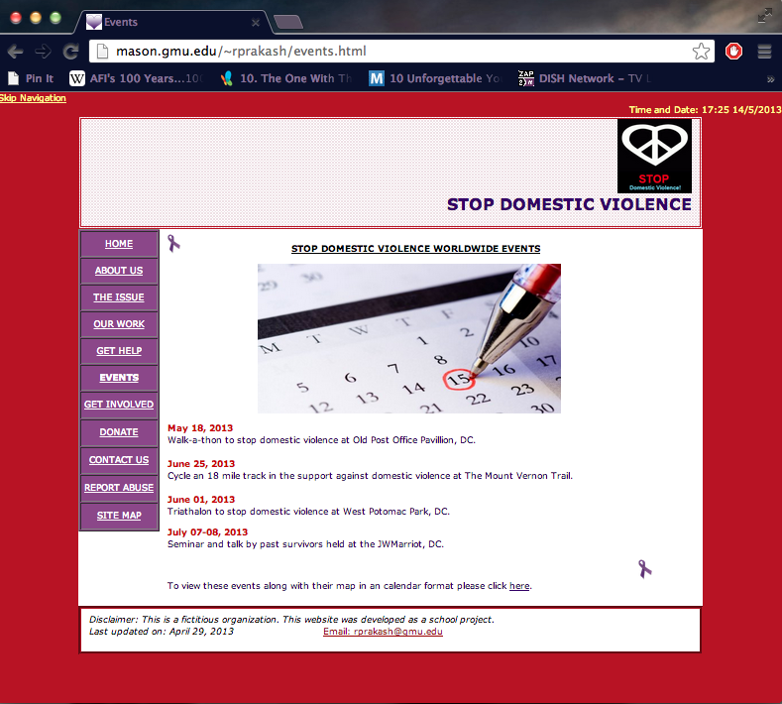

|  |  |  |
| --- | --- | --- |
| **Storyboard Template for Multimedia Product Development** | | |
| Client Name: Stop Domestic Violence | | |
| Project Title: Non-Profit Organization Website | | |
| Last Update: April 29, 2013 | | Name of Designer: Rashmee Prakash |
| Panel/Page ID: Calendar.html | | Panel/Page/Frame No: Calendar |
| Description of Copy text: | A Google calendar is embedded on the screen with the upcoming events which when clicked will also show a map on how to get there also with the details of the event. Clicking on the logo takes you back to the Homepage.  Font: Verdana, Arial, Helvetica, sans-serif  Font Size: 12 | |
| User Interactions: | A link to take you back to the events.html | |
| Hyper Links: | * index.html (clicking the logo will take you to the homepage) * Clicking “here” on the page will take you back to about_us.html | |
| Audio inclusion and controls: | None | |
| Video inclusion and controls: | None | |
| Color specifications: | Page Background: Blue Grey (#B81324)  Navigation: White (#FFF);  Skip Navigation Link, Time and Date: #FF9  Body: Heading: Black, other content : dark purple (#306)  Hyperlink/Hover Link: White(#FFF)/Pink(#639)  Header: Border: 6px double #B81324, Background image: Stripes.png  Footer: background-color: #FFF, border:6px groove #B81324; Disclaimer: Black(#000), Email id: Deep red(#900) | |
| Panel Layout | | |

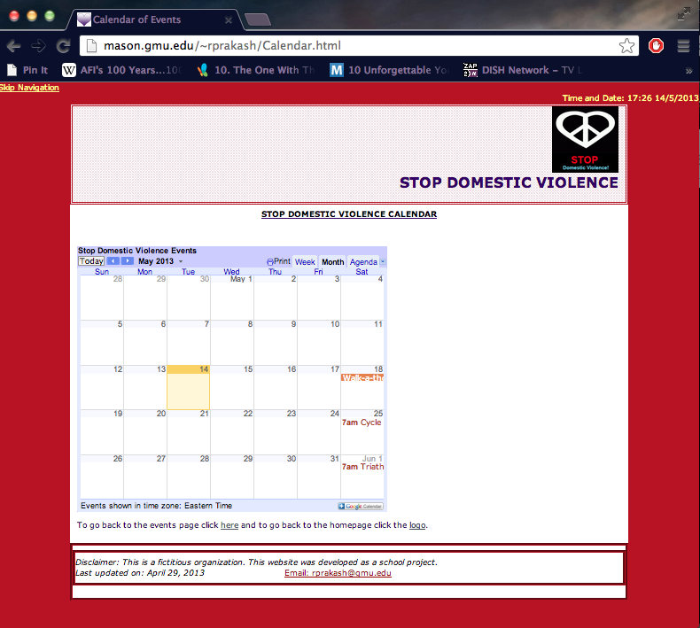

|  |  |  |
| --- | --- | --- |
| **Storyboard Template for Multimedia Product Development** | | |
| Client Name: Stop Domestic Violence | | |
| Project Title: Non-Profit Organization Website | | |
| Last Update: April 29, 2013 | | Name of Designer: Rashmee Prakash |
| Panel/Page ID: donate.html | | Panel/Page/Frame No: Donate |
| Description of Copy text: | Home Text: Ways to make donations to the organization. Clicking on the Paypal link will take you to [www.paypal.com](http://www.paypal.com). Ribbons at top and bottom to take you to previous and next page. Clicking on the logo takes you back to the Homepage.  Font: Verdana, Arial, Helvetica, sans-serif  Font Size: 12 | |
| User Interactions: | Navigation buttons, on the left side of each page.  Flash animation, with user-controlled button. Press button to continue playing the animation to the end. | |
| Hyper Links: | * index.html(clicking the logo will also take you to the homepage) * about_us.html * issue.html * our_work.html * get_help.html * get_involved.html * events.html * donate.html * contact_us.html * report_abuse.html * site_map.html | |
| Audio inclusion and controls: | None | |
| Video inclusion and controls: | None | |
| Color specifications: | Page Background: Blue Grey (#B81324)  Navigation: White (#FFF);  Skip Navigation Link, Time and Date: #FF9  Body: Heading: Black, other content : dark purple (#306)  Hyperlink/Hover Link: White(#FFF)/Pink(#639)  Header: Border: 6px double #B81324, Background image: Stripes.png  Sidebar: background-color: #8B4789  Footer: background-color: #FFF, border:6px groove #B81324; Disclaimer: Black(#000), Email id: Deep red(#900) | |
| Panel Layout | | |

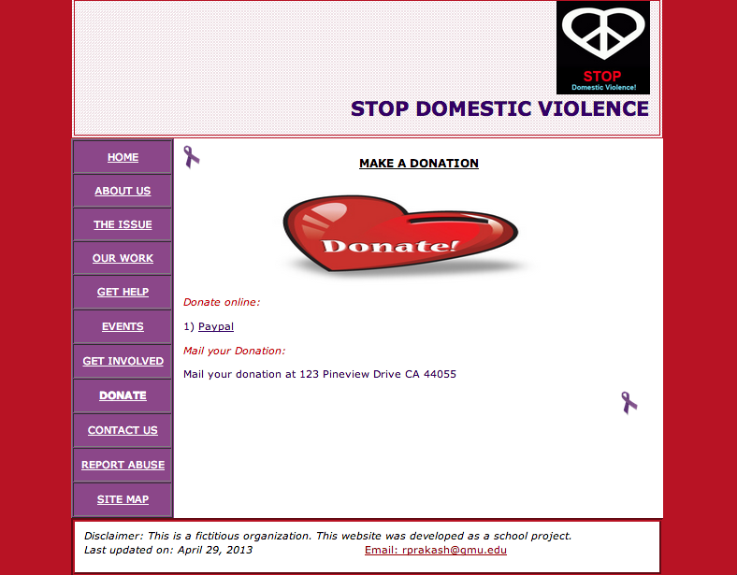

|  |  |  |
| --- | --- | --- |
| **Storyboard Template for Multimedia Product Development** | | |
| Client Name: Stop Domestic Violence | | |
| Project Title: Non-Profit Organization Website | | |
| Last Update: April 29, 2013 | | Name of Designer: Rashmee Prakash |
| Panel/Page ID: contact_us.html | | Panel/Page/Frame No: Contact Us |
| Description of Copy text: | Home Text: How to contact the organization.  Font: Verdana, Arial, Helvetica, sans-serif  Font Size: 12 | |
| User Interactions: | Navigation buttons, on the left side of each page. Ribbons at top and bottom to take you to previous and next page. Clicking on the logo takes you back to the Homepage.  Flash animation, with user-controlled button. Press button to continue playing the animation to the end. | |
| Hyper Links: | * index.html(clicking the logo will also take you to the homepage) * about_us.html * issue.html * our_work.html * get_help.html * get_involved.html * events.html * donate.html * contact_us.html * report_abuse.html * site_map.html | |
| Audio inclusion and controls: | None | |
| Video inclusion and controls: | None | |
| Color specifications: | Page Background: Blue Grey (#B81324)  Navigation: White (#FFF);  Skip Navigation Link, Time and Date: #FF9  Body: Heading: Black, other content : dark purple (#306)  Hyperlink/Hover Link: White(#FFF)/Pink(#639)  Header: Border: 6px double #B81324, Background image: Stripes.png  Sidebar: background-color: #8B4789  Footer: background-color: #FFF, border:6px groove #B81324; Disclaimer: Black(#000), Email id: Deep red(#900) | |
| Panel Layout | | |

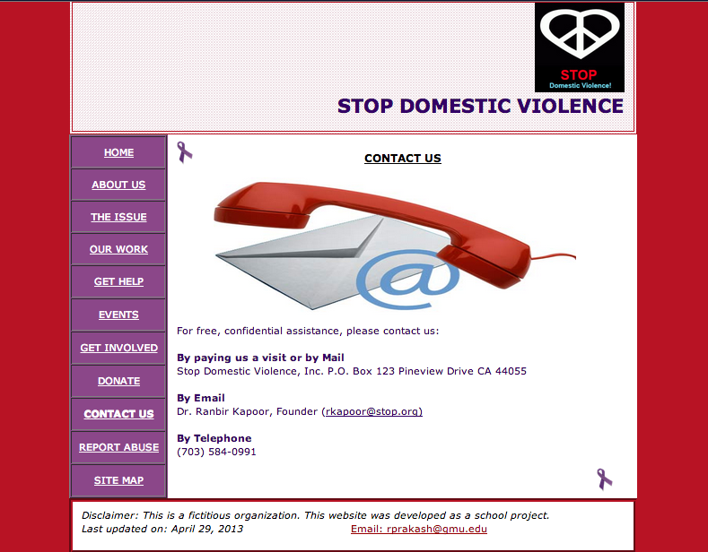

|  |  |  |
| --- | --- | --- |
| **Storyboard Template for Multimedia Product Development** | | |
| Client Name: Stop Domestic Violence | | |
| Project Title: Non-Profit Organization Website | | |
| Last Update: April 29, 2013 | | Name of Designer: Rashmee Prakash |
| Panel/Page ID: report_abuse.html | | Panel/Page/Frame No: Report Abuse |
| Description of Copy text: | Home Text: How to report ongoing abuse.  Font: Verdana, Arial, Helvetica, sans-serif  Font Size: 12 | |
| User Interactions: | Navigation buttons, on the left side of each page. Ribbons at top and bottom to take you to previous and next page. Clicking on the logo takes you back to the Homepage.  Flash animation, with user-controlled button. Press button to continue playing the animation to the end. | |
| Hyper Links: | * index.html(clicking the logo will also take you to the homepage) * about_us.html * issue.html * our_work.html * get_help.html * get_involved.html * events.html * donate.html * contact_us.html * report_abuse.html * site_map.html | |
| Audio inclusion and controls: | None | |
| Video inclusion and controls: | None | |
| Color specifications: | Page Background: Blue Grey (#B81324)  Navigation: White (#FFF);  Skip Navigation Link, Time and Date: #FF9  Body: Heading: Black, other content : dark purple (#306)  Hyperlink/Hover Link: White(#FFF)/Pink(#639)  Header: Border: 6px double #B81324, Background image: Stripes.png  Sidebar: background-color: #8B4789  Footer: background-color: #FFF, border:6px groove #B81324; Disclaimer: Black(#000), Email id: Deep red(#900) | |
| Panel Layout | | |

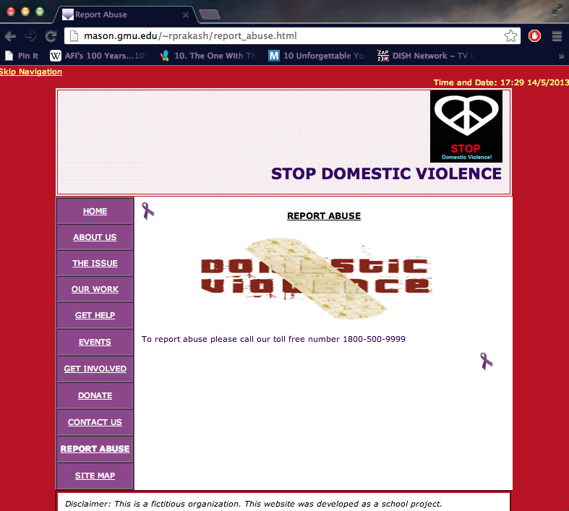

|  |  |  |
| --- | --- | --- |
| **Storyboard Template for Multimedia Product Development** | | |
| Client Name: Stop Domestic Violence | | |
| Project Title: Non-Profit Organization Website | | |
| Last Update: April 29, 2013 | | Name of Designer: Rashmee Prakash |
| Panel/Page ID: site_map.html | | Panel/Page/Frame No: Site Map |
| Description of Copy text: | Home Text: How to get involved with the organization.  Font: Verdana, Arial, Helvetica, sans-serif  Font Size: 12 | |
| User Interactions: | Navigation links. Ribbons at top and bottom to take you to previous and first page. Clicking on the logo takes you back to the Homepage.  Flash animation, with user-controlled button. Press button to continue playing the animation to the end. | |
| Hyper Links: | * index.html(clicking the logo will also take you to the homepage) * about_us.html * wallpapaer.html * issue.html * our_work.html * get_help.html * get_involved.html * events.html * calendar.html * donate.html * contact_us.html * report_abuse.html * site_map.html * references.html | |
| Audio inclusion and controls: | None | |
| Video inclusion and controls: | None | |
| Color specifications: | Page Background: Blue Grey (#B81324)  Navigation: Dark Purple (#306);  Skip Navigation Link, Time and Date: #FF9  Body: Heading: Black, other content : dark purple (#306)  Hyperlink/Hover Link: White(#FFF)/Pink(#639)  Header: Border: 6px double #B81324, Background image: Stripes.png  Footer: background-color: #FFF, border:6px groove #B81324; Disclaimer: Black(#000), Email id: Deep red(#900) | |
| Panel Layout | | |

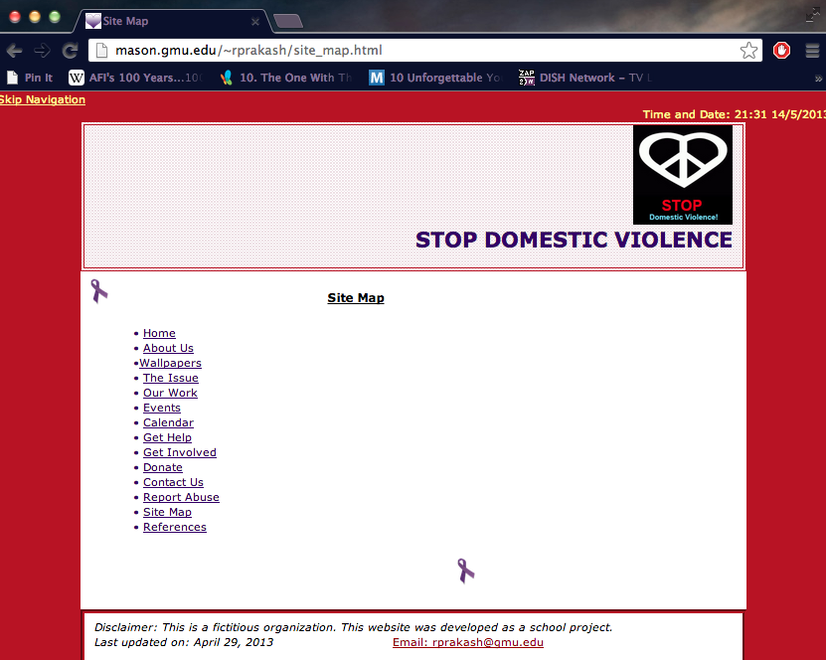

|  |  |  |
| --- | --- | --- |
| **Storyboard Template for Multimedia Product Development** | | |
| Client Name: Stop Domestic Violence | | |
| Project Title: Non-Profit Organization Website | | |
| Last Update: April 29, 2013 | | Name of Designer: Rashmee Prakash |
| Panel/Page ID: references.html | | Panel/Page/Frame No: References |
| Description of Copy text: | Home Text: works cited  Font: Verdana, Arial, Helvetica, sans-serif  Font Size: 12 | |
| User Interactions: | Navigation links. Ribbons at the bottom to take you back to the site map and logo to take you to the home page.  Flash animation, with user-controlled button. Press button to continue playing the animation to the end. | |
| Hyper Links: | * index.html(clicking the logo will also take you to the homepage) * image link: ribbon to take you back to site_map.html | |
| Audio inclusion and controls: | None | |
| Video inclusion and controls: | None | |
| Color specifications: | Page Background: Blue Grey (#B81324)  Navigation: Dark Purple (#306);  Skip Navigation Link, Time and Date: #FF9  Body: Heading: Black, other content : dark purple (#306)  Header: Border: 6px double #B81324, Background image: Stripes.png  Footer: background-color: #FFF, border:6px groove #B81324; Disclaimer: Black(#000), Email id: Deep red(#900) | |
| Panel Layout | | |

